Standards for Mathematical Practices (Speakers: Ms. Lori Cargile, Curriculum and Instruction doctoral student, UC; and Dr. Kimya Moyo, Educational Consultant, Director of the Sakofa Educational Enrichment Program, and CEEMS Resource Person; June 25th, 2015, 1:00 pm–4:00 pm)
Ms. Lori Cargile is a graduate of Spelman College and also earned an Master of Arts in Teaching (M.A.T.) from Emory University in Atlanta. She is currently a Curriculum and Instruction doctoral student at the UC. She was a classroom teacher for 10 years and also served as a Lead Teacher for 4 years for Cincinnati Public Schools. Most recently, she was a middle school assistant principal for 4 years in the North College Hill School district.
Dr. Kimya Moyo is an Educational Consultant for mathematics education and classroom pedagogy. She is a National Board Certified Teacher in the area of high school mathematics. Her experience as an educator includes 30 year of service to Cincinnati Public Schools. During that time she was the recipient of the 2008 Lawrence Hawkins Educator of the Year Award. Currently she is Director of the Sankofa Educational Enrichment Program – a Saturday school that teaches critical thinking through African and African American history since 1993. She also tutors math at DePaul Cristo Rey High School and is a member of the Cincinnati Enhanced Engineering Math and Science Program (CEEMS) Resource Team.
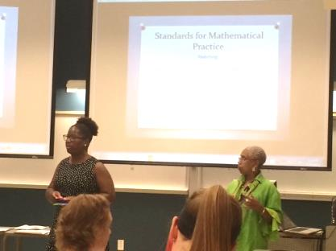
Figure 1: Ms. Lori Cargile and Dr. Moyo Giving an Overview of SMP
This session began with participant taking a pretest over the Standards for Mathematical Practices (SMP) followed by a brief review/introduction to the standards. After the introduction, participants were given a set of lesson overviews and worked in small groups to determine which practice was being used. The presenters and participants concluded that lessons do not fall under only one SMP, but can capture multiple standards in one lesson.
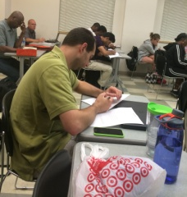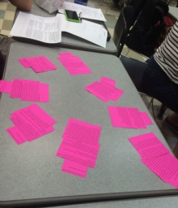
Figure 2: Participants Work on Pretest Figure 3: The RET Groups SMP Sort
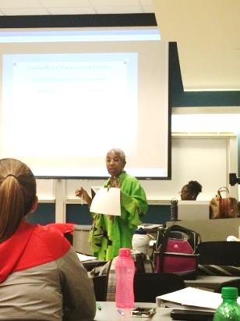
Figure 4: Dr. Moyo Poses Thoughtful Questions to Participants
Next, the participants watched an excerpt of Dan Meyer’s Ted Talk “Math Class Needs a Makeover” titled and listened to a portion of the NPR Podcast, “Struggle For Smarts? How Eastern And Western Cultures Tackle Learning.” After viewing each, the participants were posed questions to begin thinking about incorporating the SMP in their classroom and at what level each participant is in full implementation. To assist participants with furthering their understanding and implementation of the SMP, several resources were given including http://www.insidemathematics.org/, United We Stand: 116 Math Problems for Groups by Tim Erickson (1996), and Get It Together: Math Problems for Groups Grades 4-12 by Equals Lawrence Hall of Science (1989).
Finally, the participants were encouraged to put their newly acquired information to practice. In small groups, participants were given a standard and required to create a visual representation of what the standard looks like. This could have been done in the form of a picture, example, or other representation selected from the group. This activity was immediately followed by a gallery walk activity, brief discussion, and closing remarks by Dr. Mayo and Lori Cargile.

